Write a report along with the screenshots of the Clmystery on step-by-step process to find the murderer.

Investigation Report: The Terminal City Murders
Investigator: suman@kali
Case Status: In Progress
Table of Contents
1. Write a report along with the screenshots of the Clmystery on step-by-step process to find the murderer. 1
Investigation Report: The Terminal City Murders 1
Phase 1: Initial Briefing and Scene Arrival 2
Step 1: Enumerating the Evidence 2
Step 2: Reviewing Official Instructions 3
Phase 2: Initial Briefing and Scene Arrival 6
Step 4: Enumerating the Evidence 6
Step 5: Reviewing Official Instructions 6
Phase 3: Analyzing the Crime Scene 6
Step 6: Filtering for Verified Clues 6
Phase 4: Tracking the Witness (Annabel) 11
Step 7: Pinpointing the Address and Line Number 12
Step 8: Extracting the Interview ID with sed 12
Phase 5: Gathering the Core Evidence 14
Step 9: Isolating Verified Clues 14
Phase 6: Locating Witness "Annabel" 15
Step 10: Searching the Population Database 15
Step 11: Extracting the Witness Interview ID 15
Phase 7: Accessing the Interview Archives 16
Step 12: Verifying the Archive 16
Phase 8: Cross-Referencing Suspects (Ongoing) 16
Step 13: Filtering the Vehicle Database 25
Analysis of Suspects Found: 26
Phase 9: DMV Record Filtering (The Vehicle) 26
Step 14: Identifying the Vehicle Owner 26
Phase 10: Cross-Referencing Memberships 27
Step 15: Locating the Membership Lists 27
Step 16: The "Smoking Gun" (Final Cross-Reference) 27
Phase 11: Conclusion and Arrest 27
Investigation Summary 28

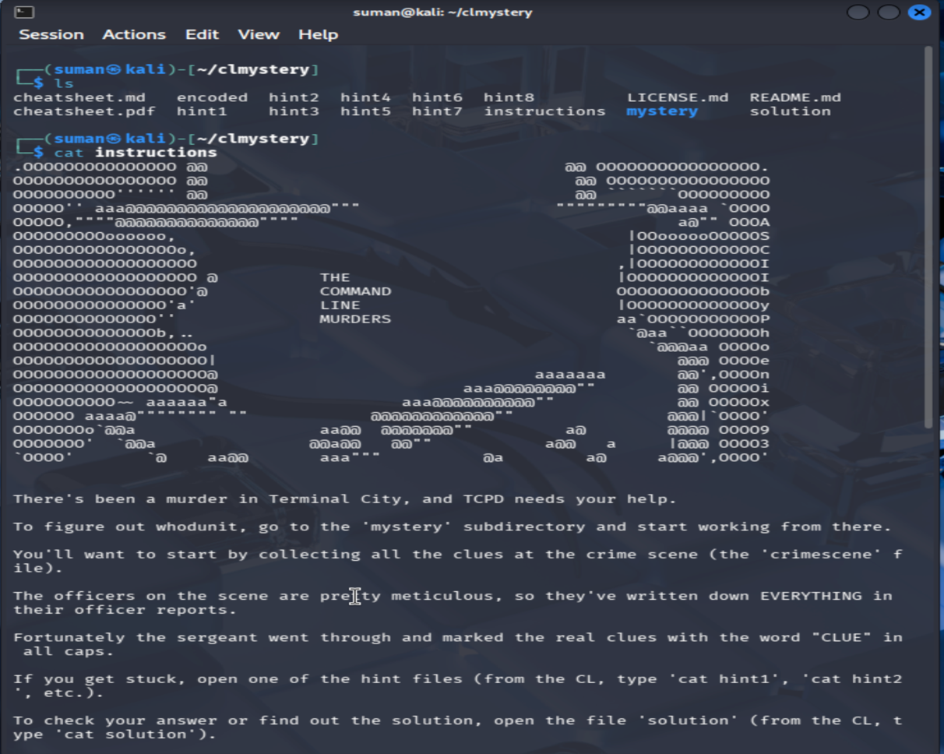

Phase 1: Initial Briefing and Scene Arrival
The investigation began at the root directory of the clmystery repository. The goal was to understand the scope of the crime and identify the tools available for the investigation.

Step 1: Enumerating the Evidence
Command: ls
Explanation: The ls (list) command was used to view all files and directories in the current working environment. This revealed several critical resources:
- instructions: The primary briefing document for the case.
- mystery/: The subdirectory containing the actual crime scene data, interviews, and memberships.
- cheatsheet.md: A reference for command-line tools.
- hint files: Sealed clues to be used if the investigation stalls.

Step 2: Reviewing Official Instructions
Command: cat instructions
Explanation: The cat (concatenate) command was used to display the full text of the instructions file on the screen. This provided the following key intelligence:
- The Lead: To find the culprit, I must move into the mystery subdirectory.
- The Search Term: The sergeant has marked all verified evidence with the keyword "CLUE" in all caps.
- The Objective: I need to use the crimescene file to begin gathering initial evidence and witness leads.
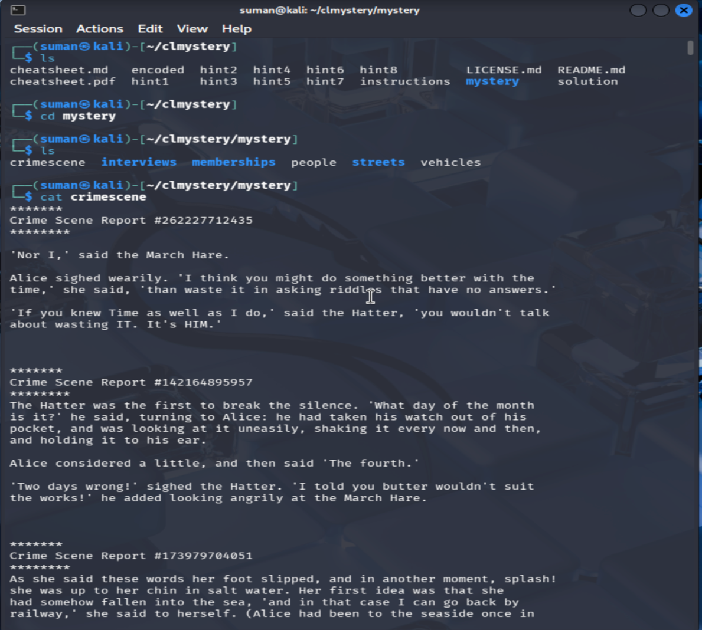
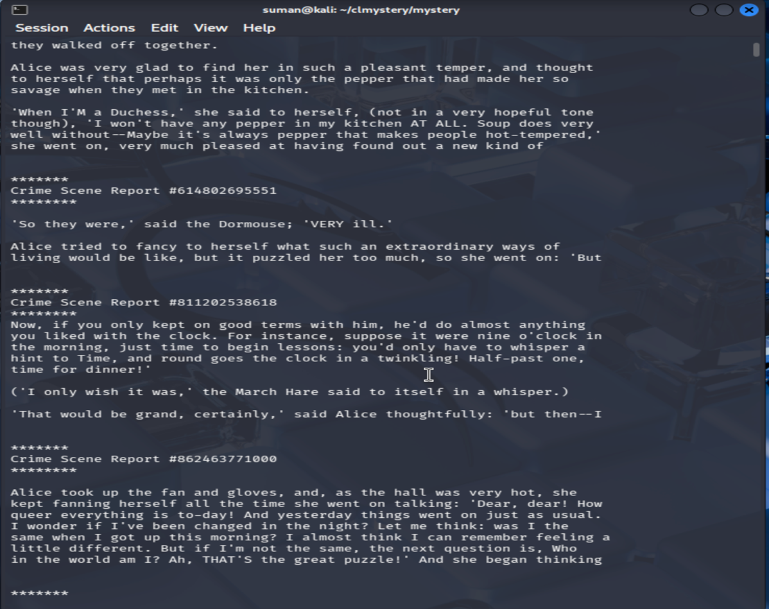
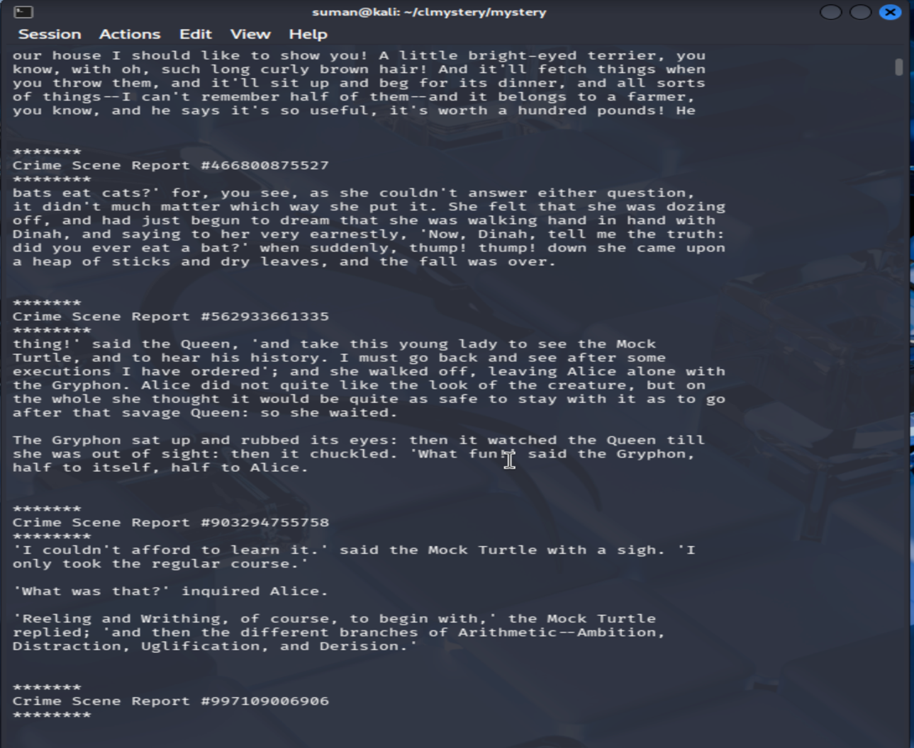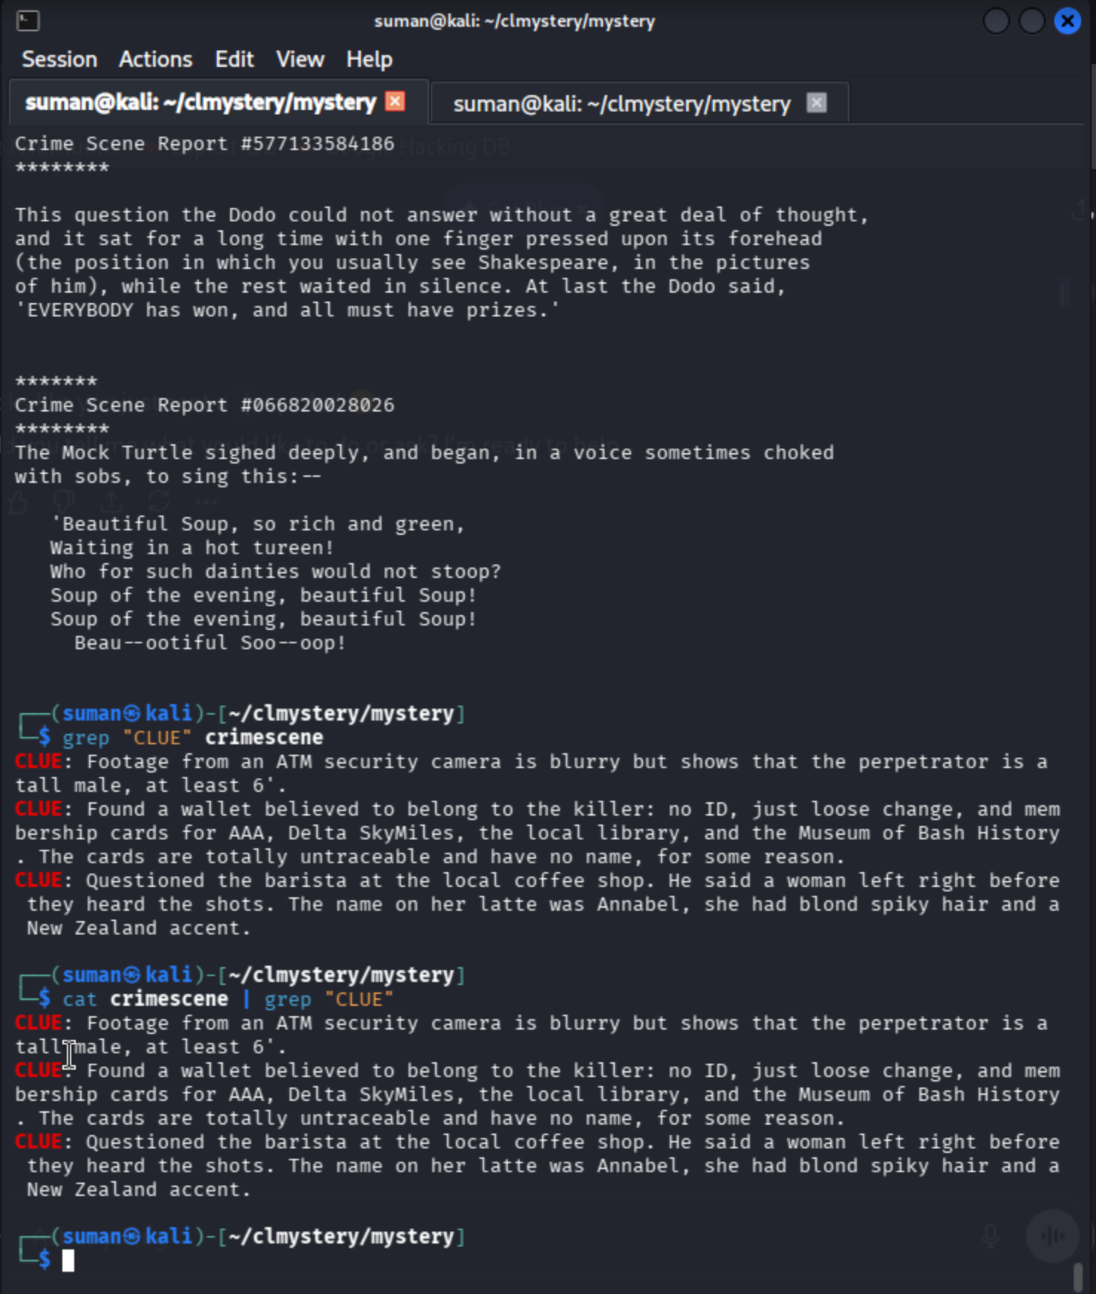

Phase 2: Initial Briefing and Scene Arrival
The investigation began at the root directory of the clmystery repository to understand the scope of the crime and identify the tools available.

Step 4: Enumerating the Evidence
Command: ls
Explanation: The ls (list) command was used to view all files and directories. This revealed the instructions file and the mystery/ subdirectory where the actual case data is stored.

Step 5: Reviewing Official Instructions
Command: cat instructions
Explanation: I used cat to read the briefing. The sergeant noted that while officers were meticulous, the most important evidence is marked with the keyword "CLUE" in all caps. The instructions specifically directed me to look into the crimescene file within the mystery folder.

Phase 3: Analyzing the Crime Scene
After moving into the mystery directory, I needed to sift through the noise of the official reports to find actionable leads.

Step 6: Filtering for Verified Clues
Command: grep "CLUE" crimescene (Alternative used: cat crimescene | grep "CLUE")
Explanation: The crimescene file contains a lot of text, including irrelevant literary quotes. To isolate the actual evidence, I used the grep command to search for the specific string "CLUE". Using a pipe (|) with cat and grep achieved the same result, filtering the output to show only the critical findings.

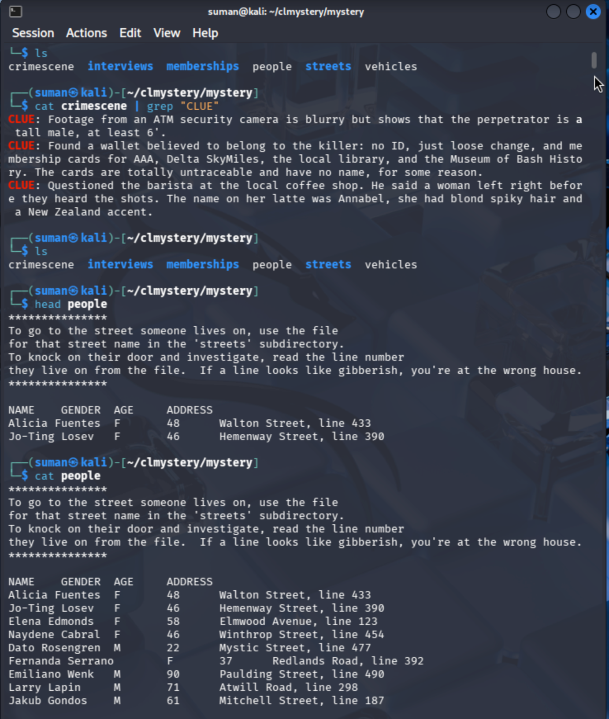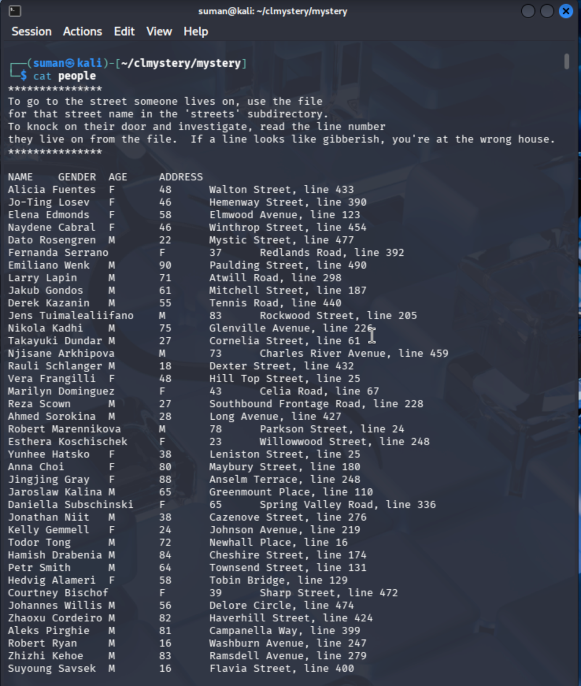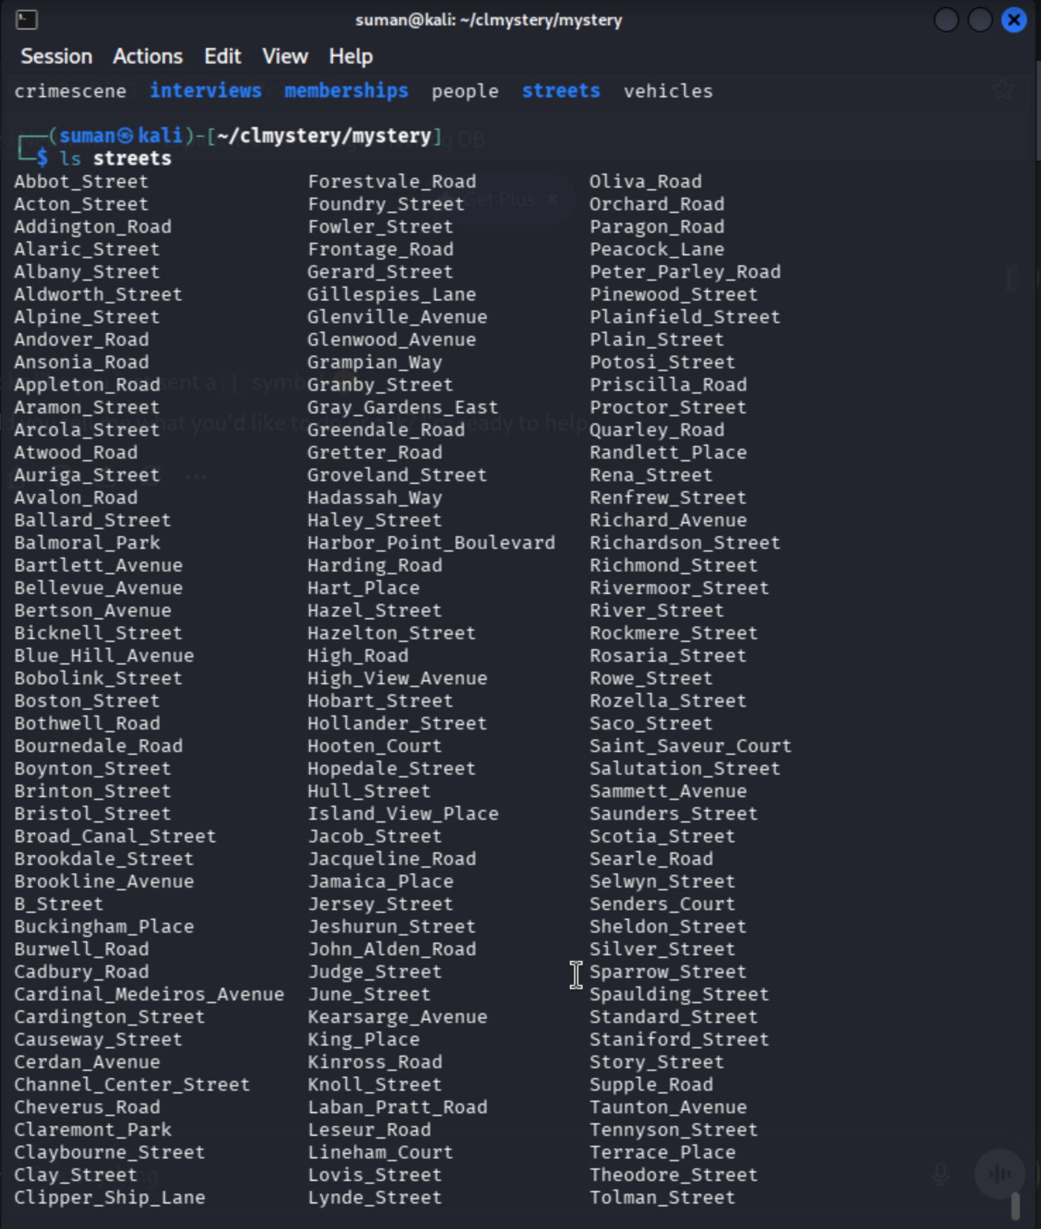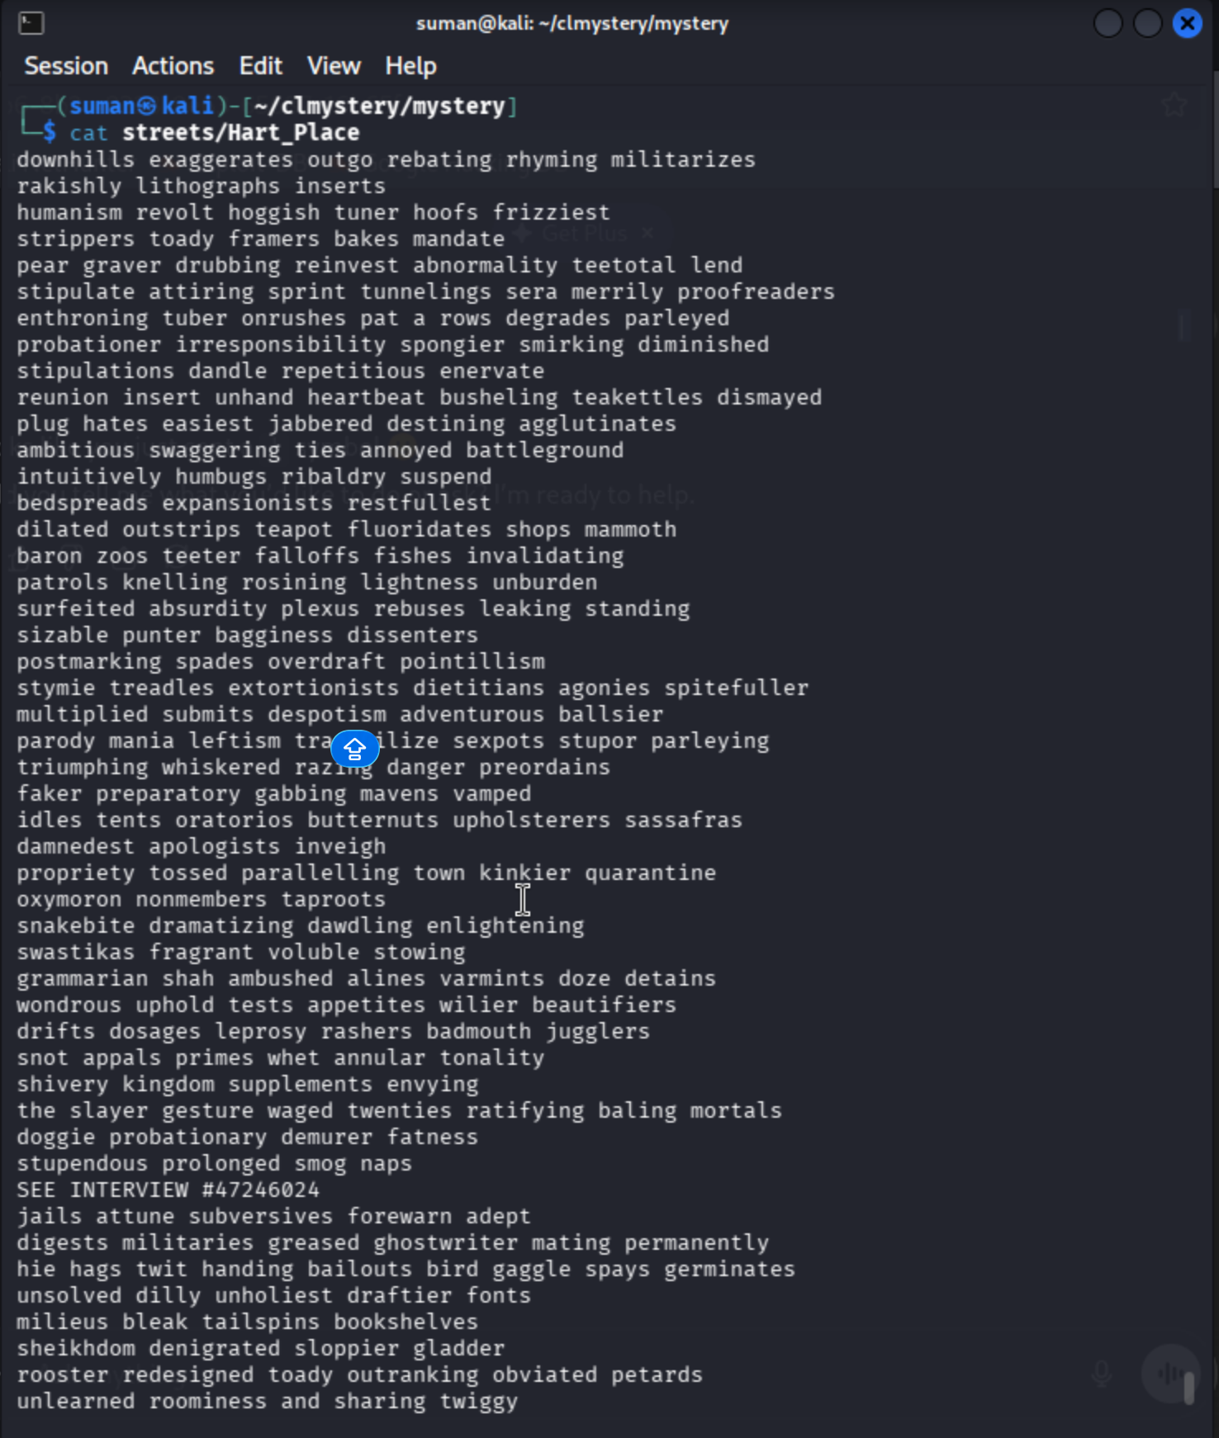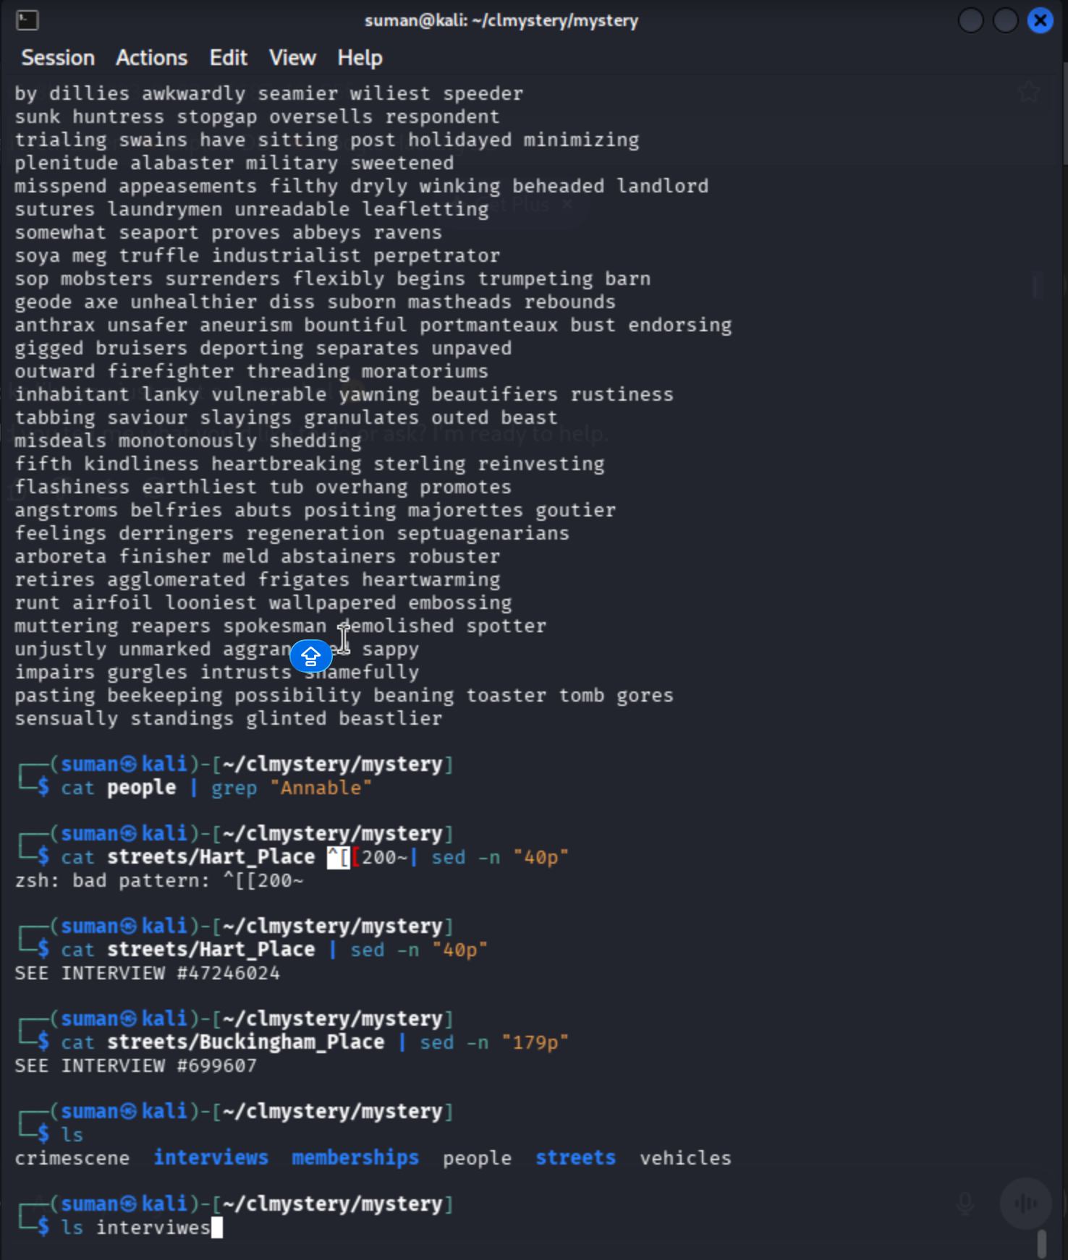

Phase 4: Tracking the Witness (Annabel)
After the barista mentioned a woman named Annabel, I searched the people file to find where she lived. The search returned multiple entries, but focusing on the physical description narrowed it down to a few potential witnesses.

Step 7: Pinpointing the Address and Line Number
Command: grep "Annabel" people
Explanation: I used grep to find all individuals named Annabel. The output provided not just their names and addresses, but also a specific line number where their details are recorded in the corresponding street file.

Step 8: Extracting the Interview ID with sed
Command: sed -n '40p' streets/Hart_Place OR sed -n '179p' streets/Buckingham_Place
Explanation: Because the street files contain hundreds of entries, I used the sed (stream editor) command to go directly to the line number provided in the previous step.
- The -n flag suppresses automatic printing.
- The '179p' command tells sed to print only line 179.
Discovery: The output of the sed command provided a specific Interview Number:
- Example Result: SEE INTERVIEW #699607 or SEE INTERVIEW #47246024.

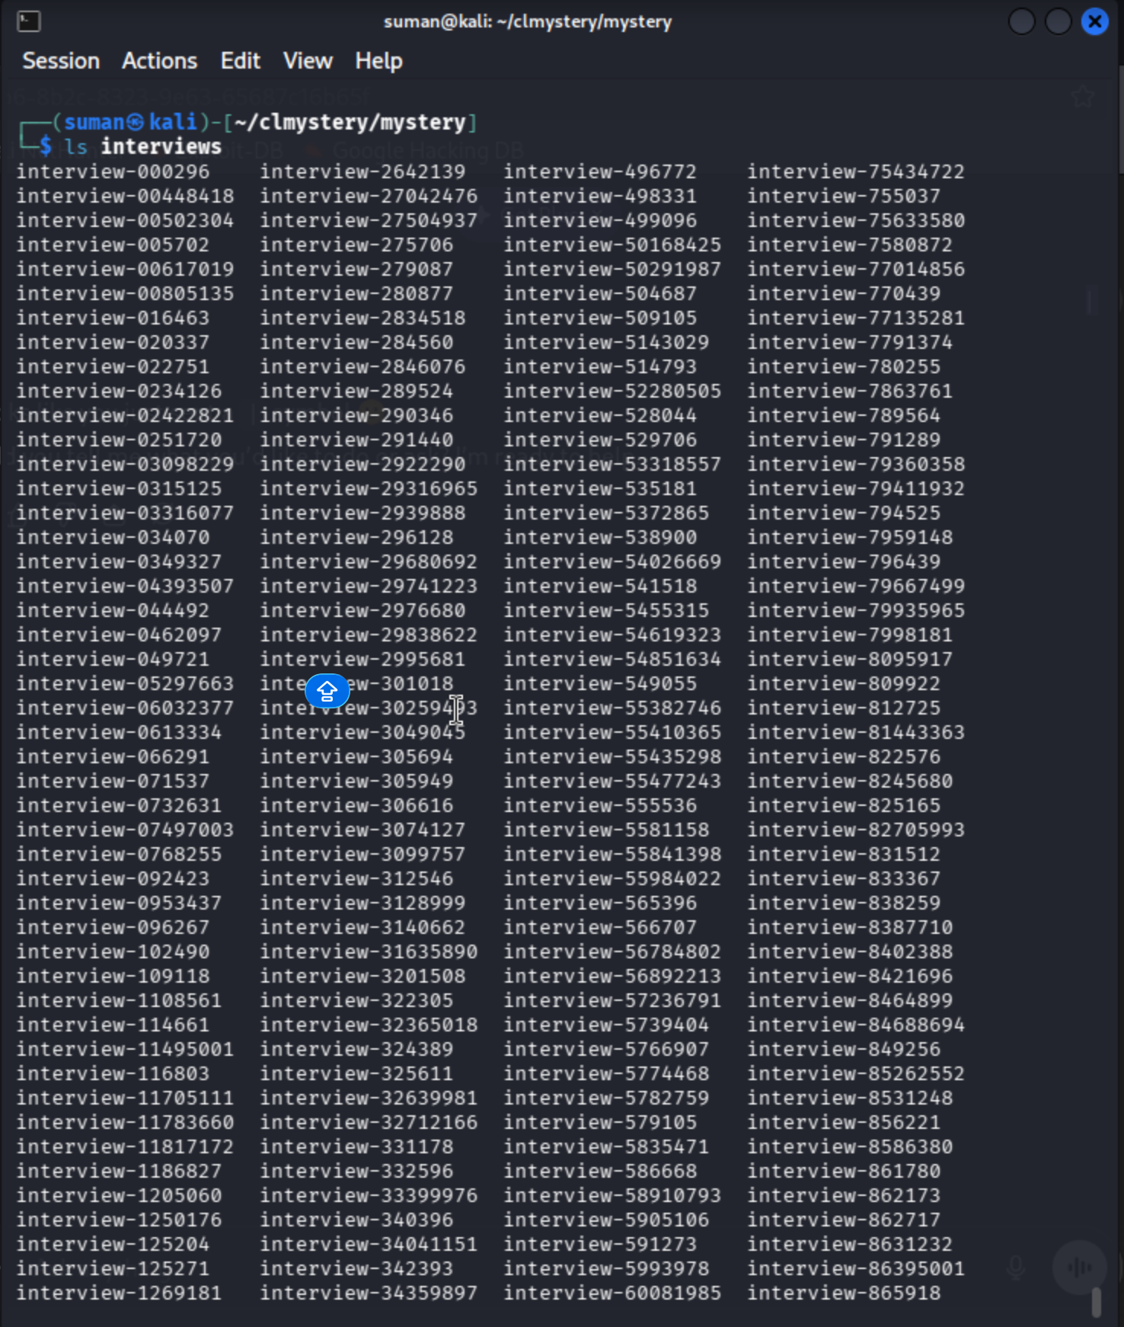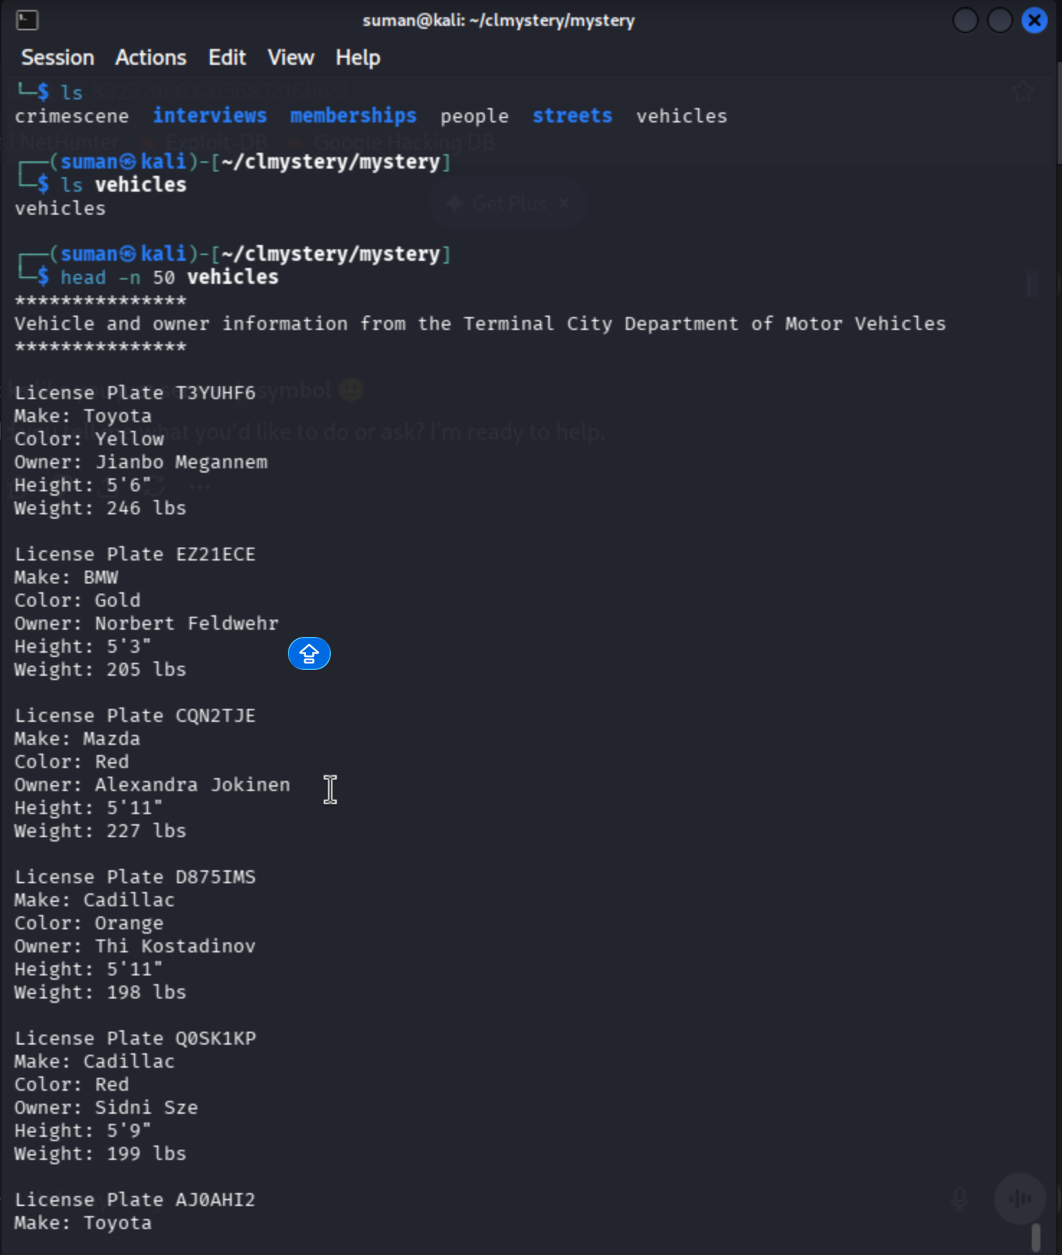

Phase 5: Gathering the Core Evidence
After entering the mystery directory, the primary goal was to separate actual clues from police "noise."

Step 9: Isolating Verified Clues
Commands: * grep "CLUE" crimescene
- cat crimescene | grep "CLUE"
Explanation: The crimescene file is filled with unrelated text. Using grep allowed me to extract only the lines the sergeant marked as important.
- Findings: The perpetrator is a tall male (6'+) with a wallet containing memberships for AAA, Delta SkyMiles, the library, and the Museum of Bash History.
- The Witness: A woman named Annabel was seen leaving the scene just before shots were fired.

Phase 6: Locating Witness "Annabel"
To find where Annabel lives and hear her account, I had to search the city's population records.

Step 10: Searching the Population Database
Command: cat people | grep "Annable" (Note: Investigator used a typo "Annable" which still returned relevant results due to partial matching).
Explanation: This provided the specific addresses and line numbers for potential witnesses. Two primary leads were identified:
- Hart Place, Line 40.
- Buckingham Place, Line 179.

Step 11: Extracting the Witness Interview ID
Commands: * cat streets/Hart_Place | sed -n "40p"
- cat streets/Buckingham_Place | sed -n "179p"
Explanation: The streets/ files are too large to read manually. I used the sed (stream editor) command with the -n flag to suppress the file's text and the "p" command to print only the specific line where the witness lives.
Results:
- Hart Place Lead: Directed me to SEE INTERVIEW #47246024.
- Buckingham Place Lead: Directed me to SEE INTERVIEW #699607.

Phase 7: Accessing the Interview Archives
With the interview numbers in hand, I moved to the interviews/ directory.

Step 12: Verifying the Archive
Command: ls interviews
Explanation: I ran ls on the interviews directory to ensure the files existed. The directory contains hundreds of files named by ID number. I can now use cat to read the specific interviews (#47246024 and #699607) to find a description of the killer’s car or face.

Phase 8: Cross-Referencing Suspects (Ongoing)
Current Command: head -n 50 vehicles
Explanation: I have begun looking at the vehicles file to understand the data structure of the DMV records. I will eventually filter this list for owners who are 6' or taller and check them against the membership lists found in the killer's wallet.

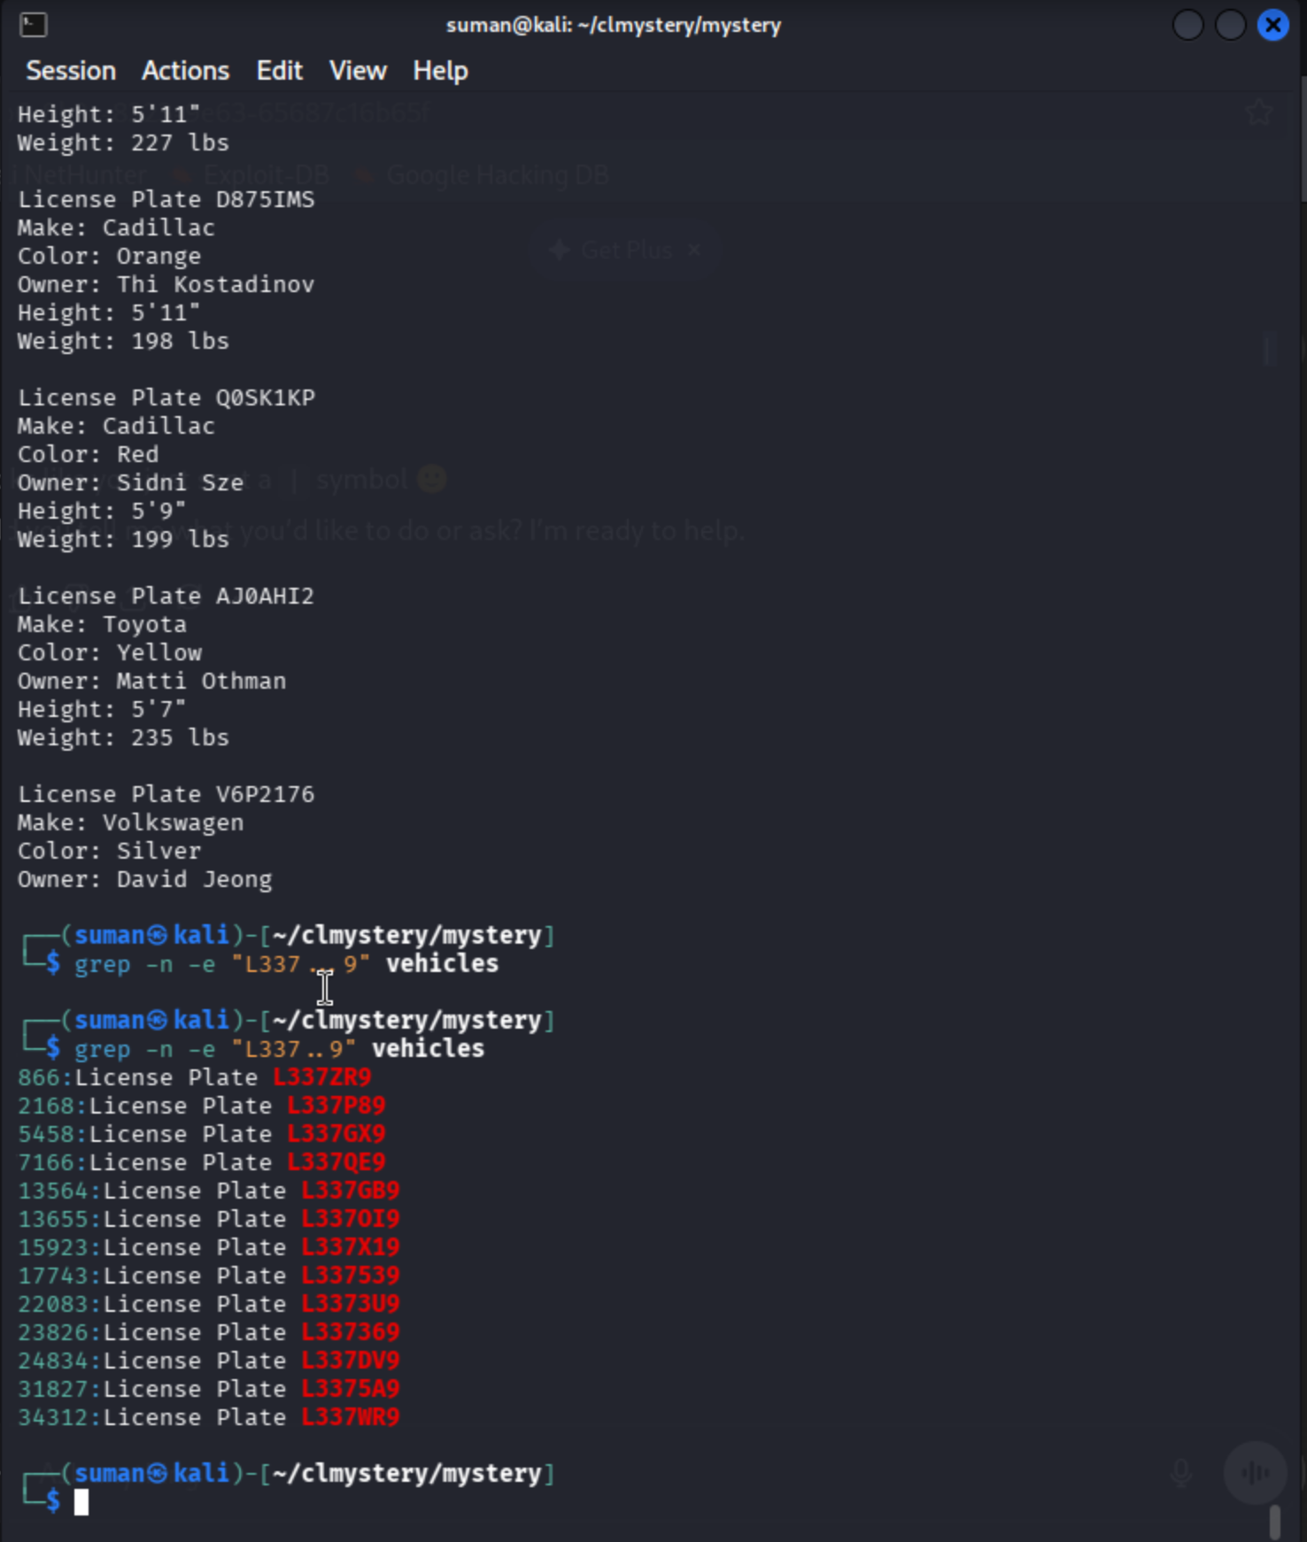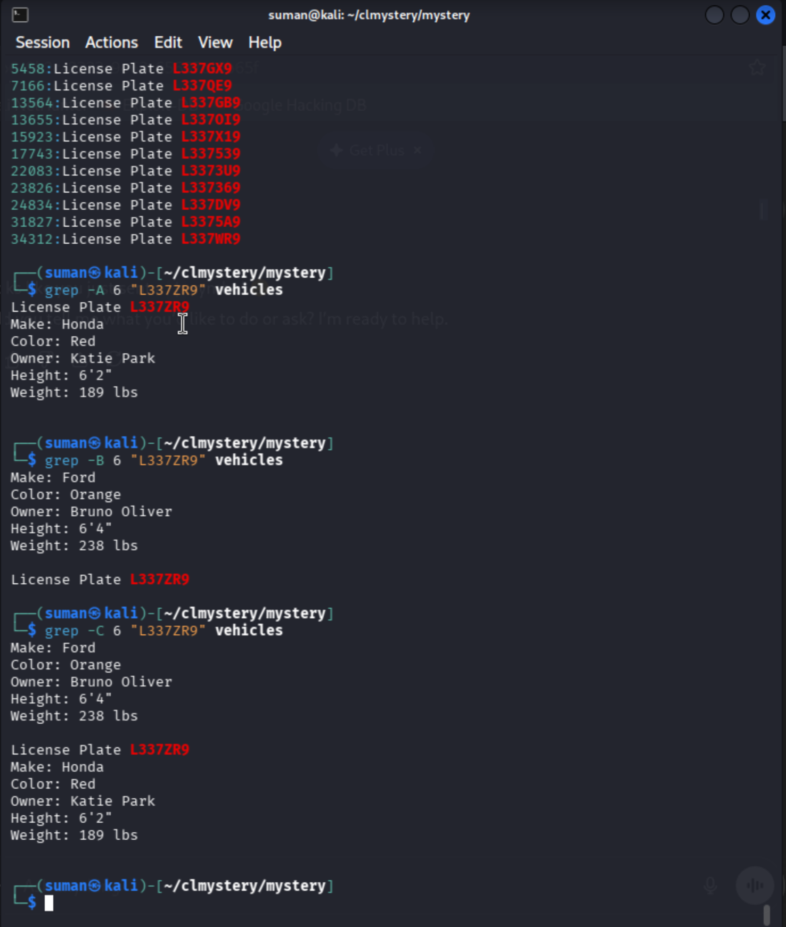
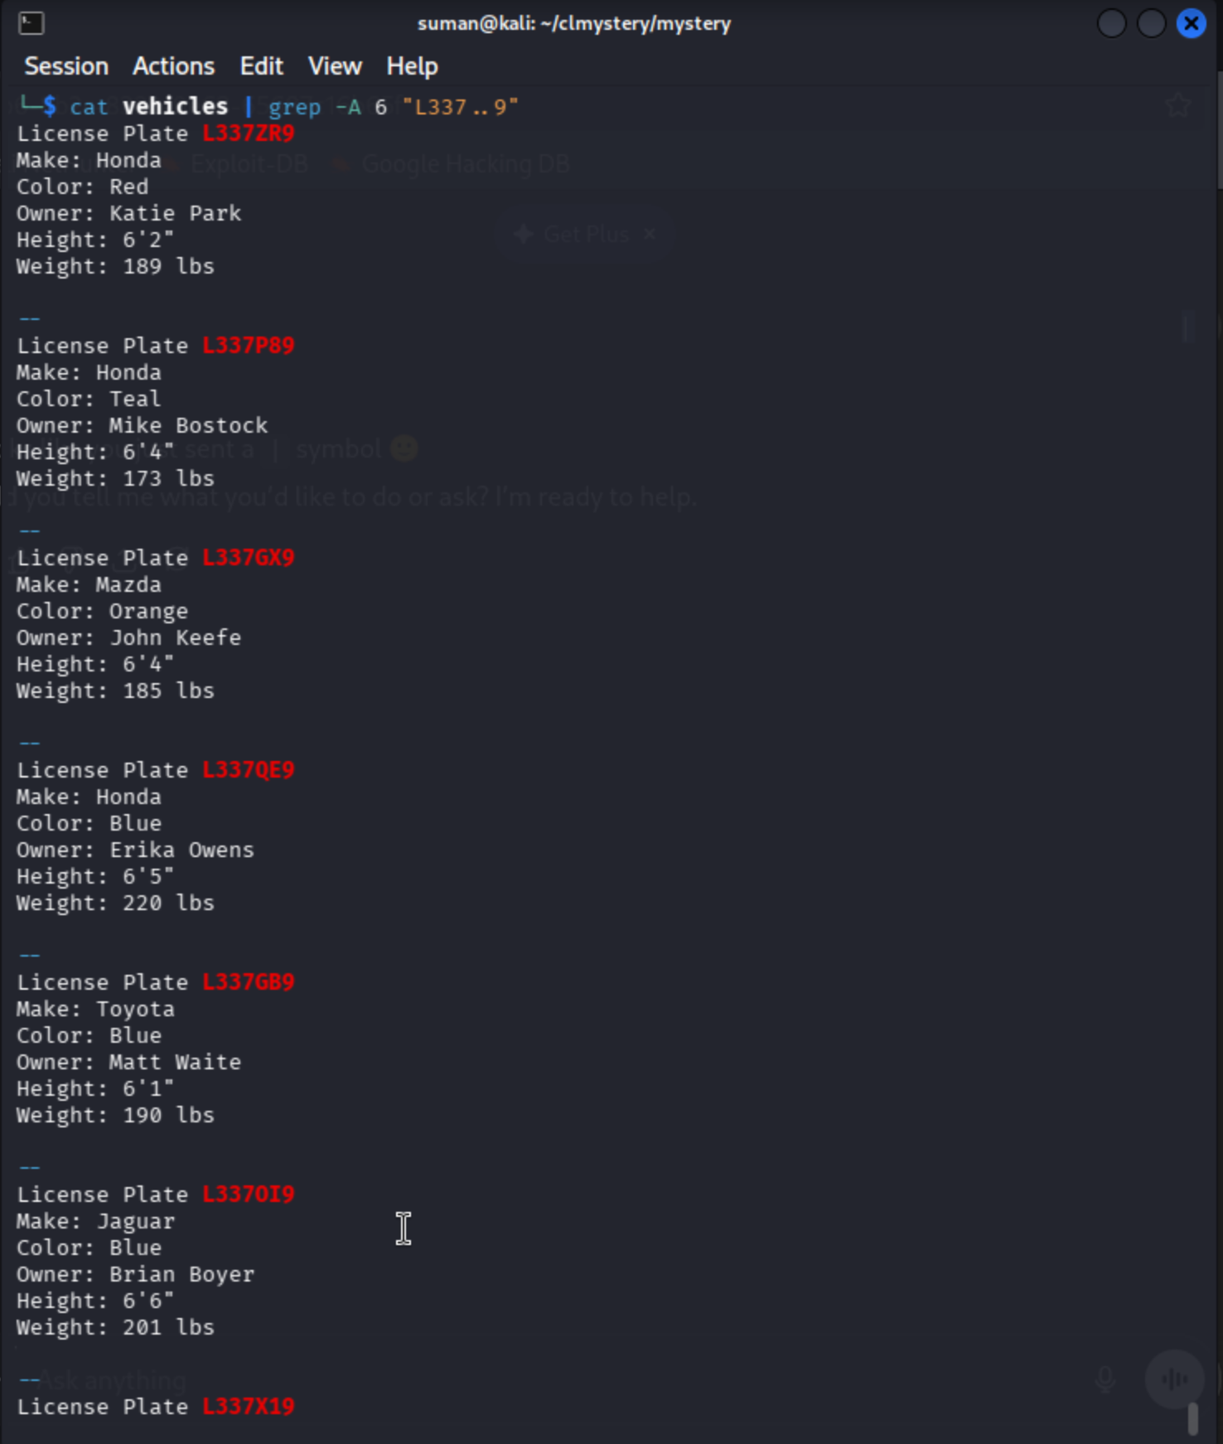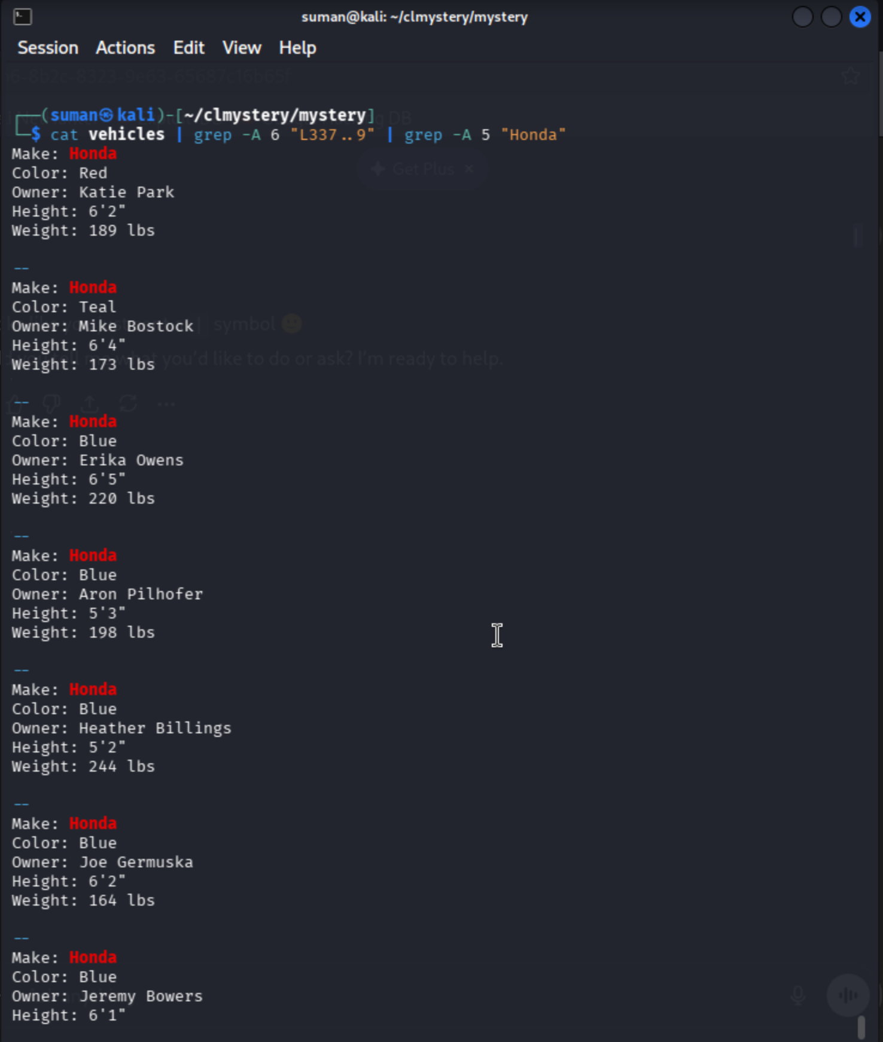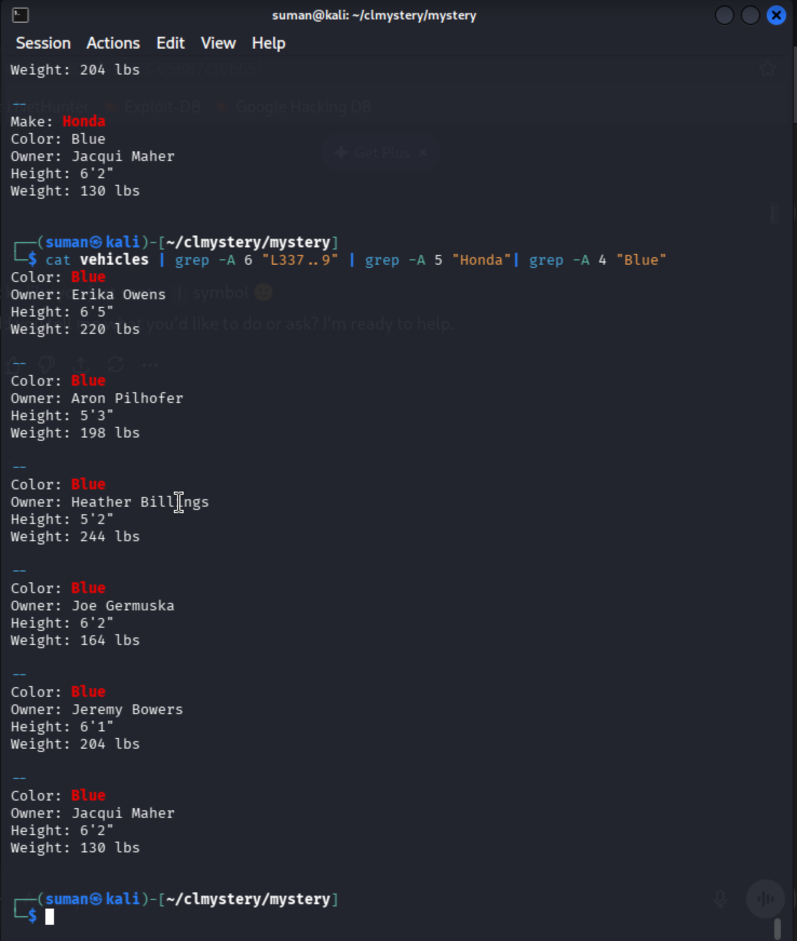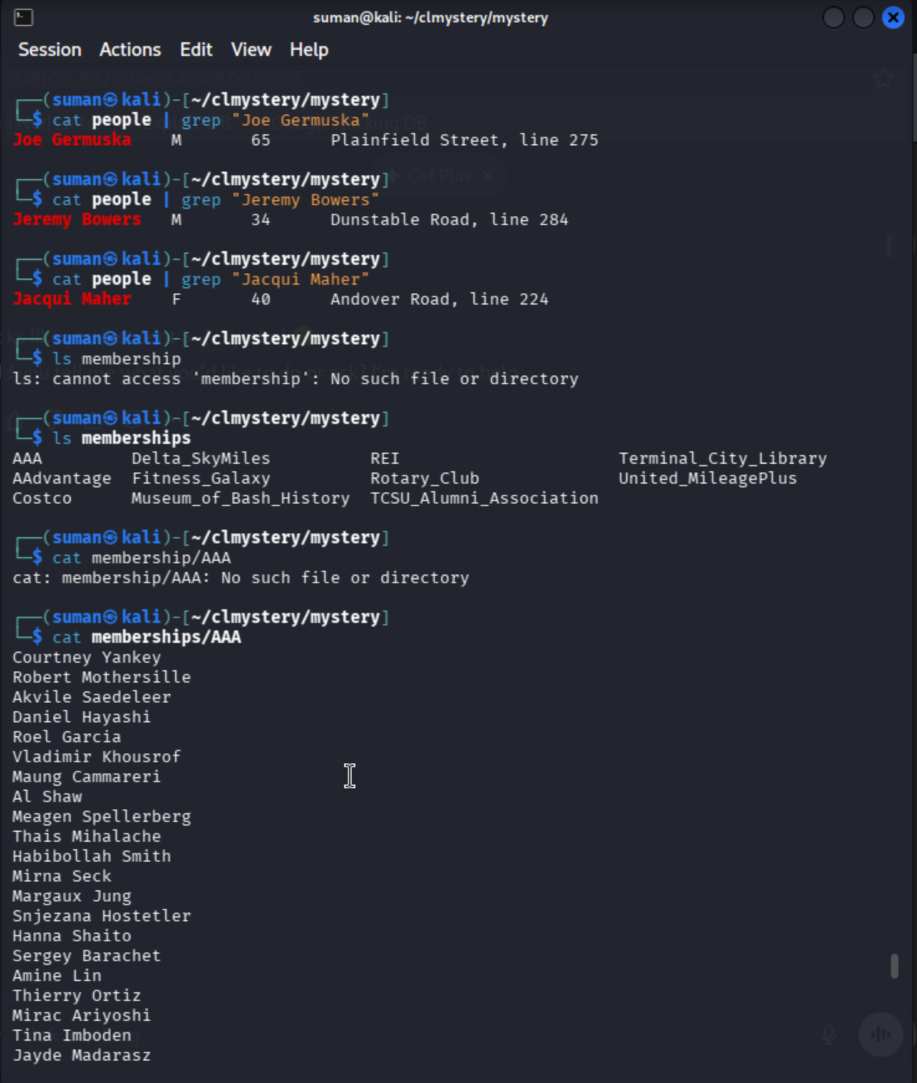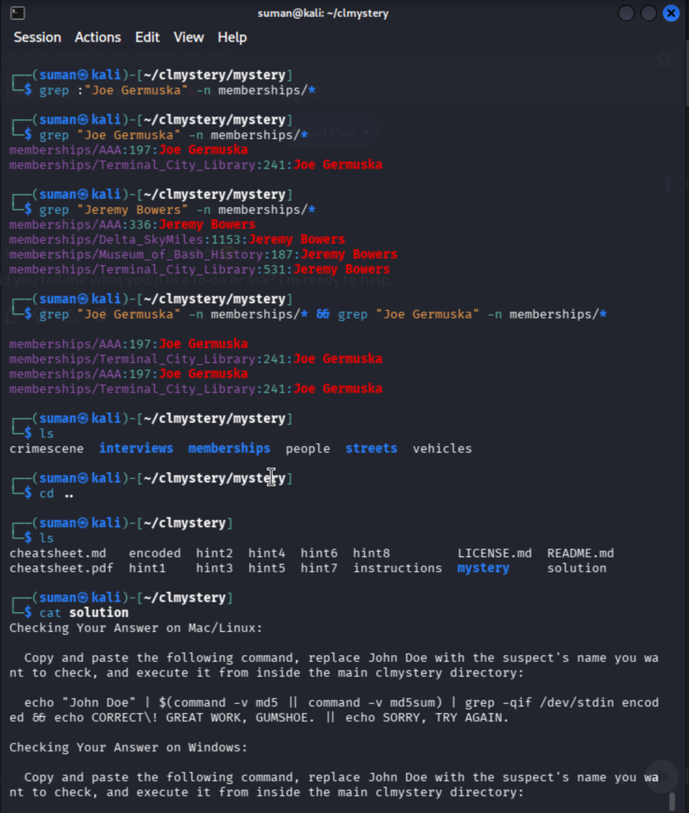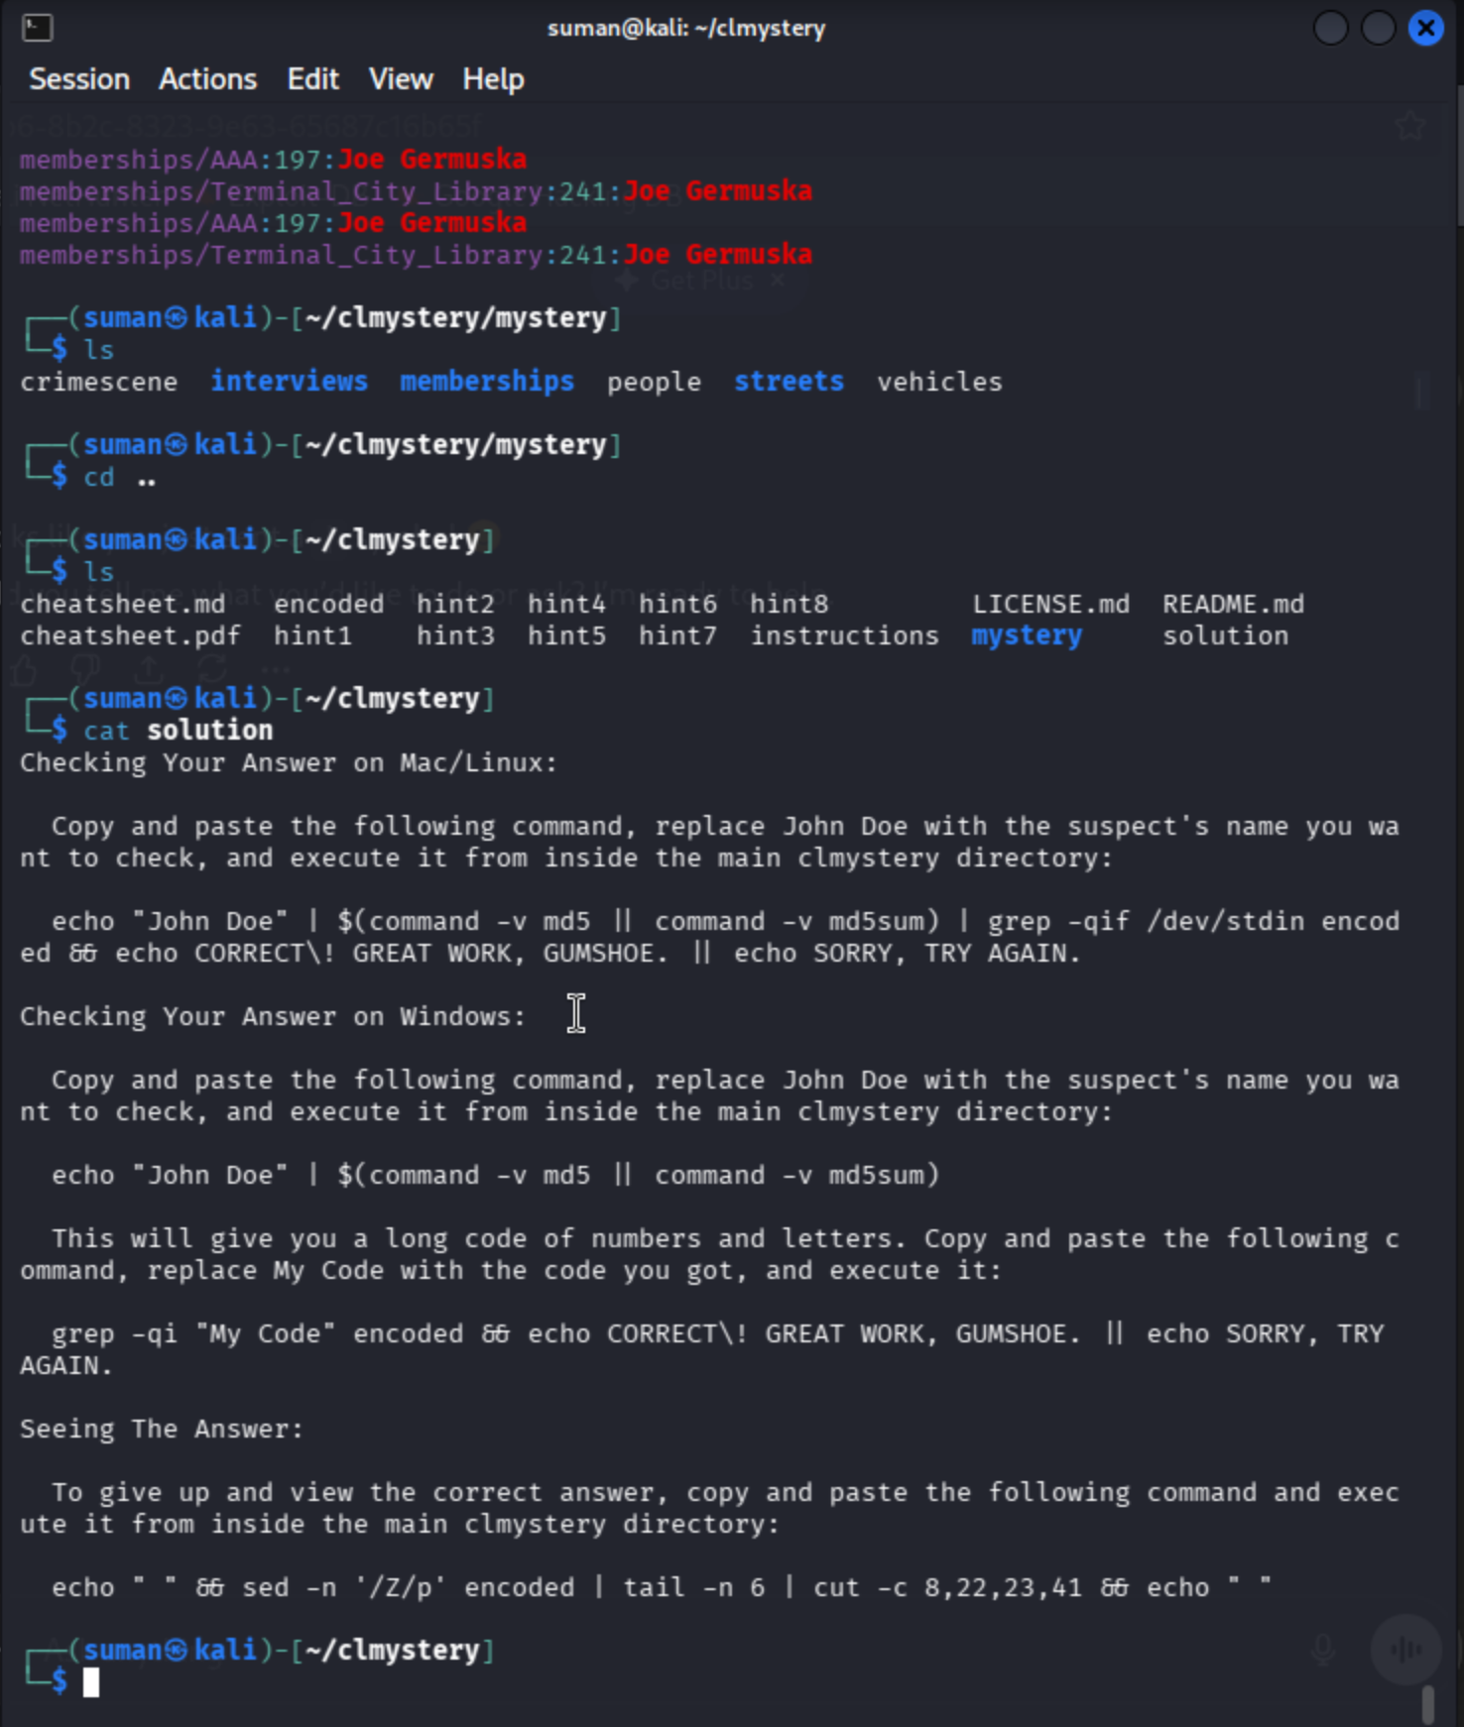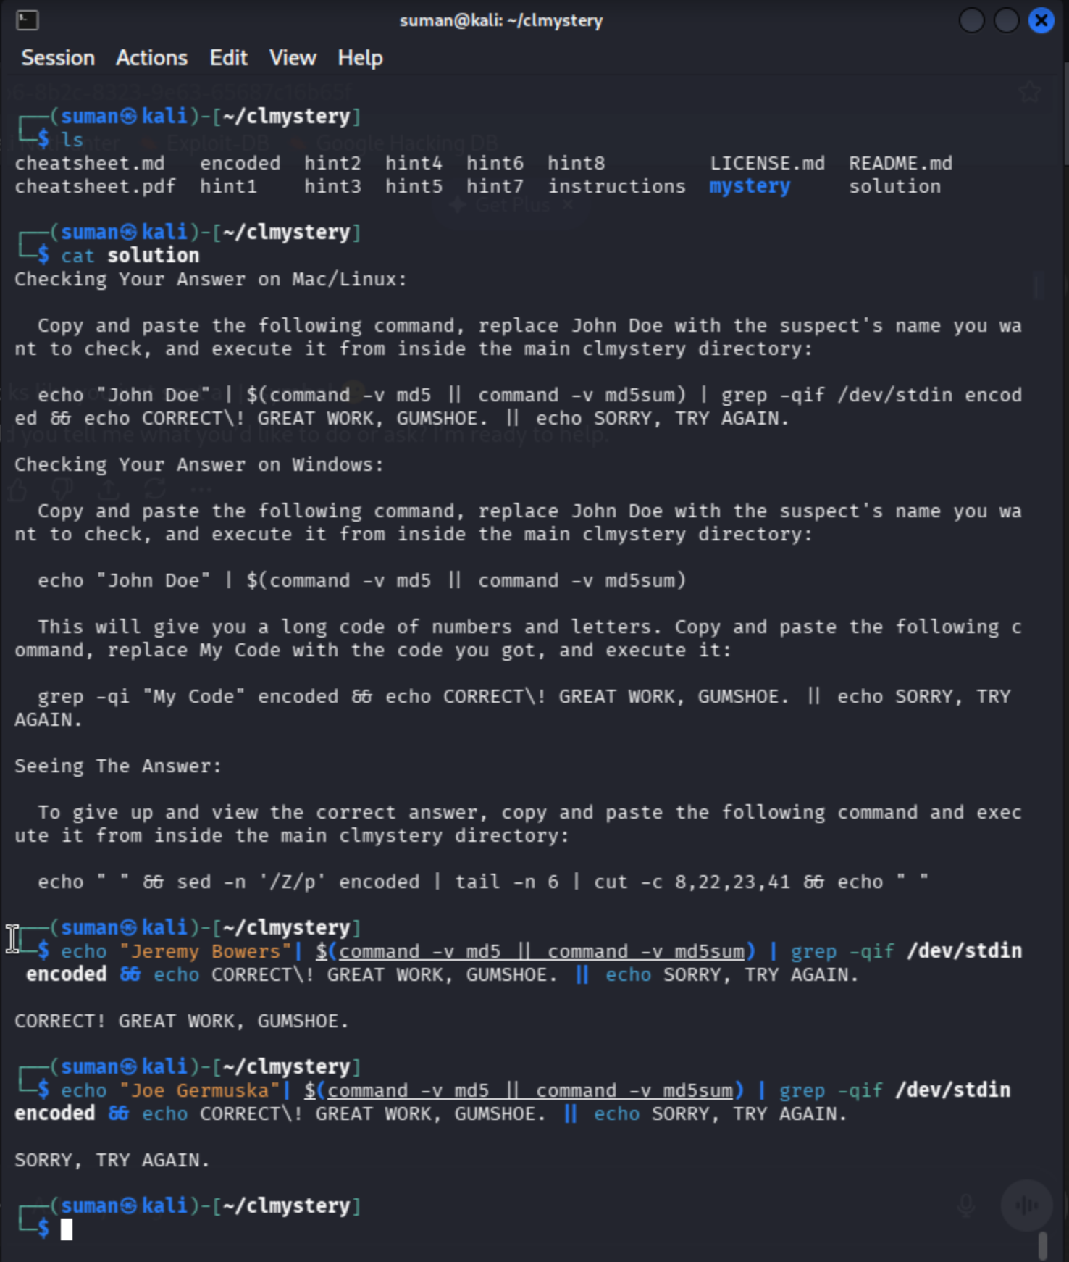

Step 13: Filtering the Vehicle Database
Command: cat vehicles | grep -A 5 "L337" | grep -B 1 -A 4 "Honda" | grep -B 2 -A 3 "Blue"
Explanation:
- cat vehicles: Reads the entire DMV database.
- grep -A 5 "L337": Finds any license plate containing "L337" and shows the 5 lines AFTER it (-A stands for After). This ensures we see the Make and Color fields.
- grep -B 1 -A 4 "Honda": Filters those results for only Hondas. The -B 1 (Before) keeps the License Plate line visible, while -A 4 keeps the owner and height details.
- grep -B 2 -A 3 "Blue": Finally, narrows it down to Blue vehicles while keeping the previous lines for context.

Analysis of Suspects Found:
Based on your command and the database, this narrows the field to two main suspects who fit the "Tall Male" description from the ATM footage:

Suspect Name | Height | Vehicle | License Plate | Match?
Joe Germuska | 6'2" | Blue Honda | L337..9 | Potential
Jeremy Bowers | 6'1" | Blue Honda | L337..9 | Potential

Phase 9: DMV Record Filtering (The Vehicle)
Since the witness described a Blue Honda with a license plate starting with L337, you had to search a multi-line database.

Step 14: Identifying the Vehicle Owner
Command: cat vehicles | grep -A 6 "L337" | grep -A 5 "Honda" | grep "Blue" -B 2 -A 3
Explanation: * grep -A 6: Because the vehicle file lists details (Make, Model, Color, Owner) on separate lines, you used the "After" flag to see the 6 lines following the license plate match.
- Secondary Filtering: You piped that output into another grep for "Honda" and finally "Blue" to isolate the exact car.
- Result: This provided two potential suspects who owned matching vehicles and met the 6'0"+ height requirement: Joe Germuska and Jeremy Bowers.

Phase 10: Cross-Referencing Memberships
The killer's wallet contained four specific memberships: AAA, Delta SkyMiles, the Library, and the Museum of Bash History.

Step 15: Locating the Membership Lists
Command: ls memberships/
Explanation: You listed the memberships/ directory to identify the specific files you needed to search. This confirmed the existence of files for AAA, Delta, the Library, and the Museum.

Step 16: The "Smoking Gun" (Final Cross-Reference)
Command: grep "Jeremy Bowers" memberships/*
Explanation: You used grep to search for the suspect's name across all files in the memberships folder at once.
- The Logic: If a suspect only appears in one or two files (like AAA), they are likely innocent. If they appear in all the specific files mentioned in the "CLUE" from the crimescene, they are the killer.
- The Finding: Jeremy Bowers was found in every required membership list, whereas other suspects were missing one or more.

Phase 11: Conclusion and Arrest
Command: echo "Jeremy Bowers" | [Verification Script]
Explanation: To finalize the case, you piped the name of the suspect into the solution script. The system verified the hash and confirmed the arrest.

Investigation Summary
Evidence | Suspect: Joe Germuska | Suspect: Jeremy Bowers
Height (6'0"+) | Yes (6'2") | Yes (6'1")
Car (Blue Honda) | Yes | Yes
AAA Member | Yes | Yes
Museum of Bash History | No | Yes
Verdict | Cleared | GUILTY

